|  |  |  |
| --- | --- | --- |
|  | **MATHEMATICS METHODS**  **YEAR 12, UNIT 3**  **TASK 2: TEST 1**  **Differentiation and Antidifferentiation**  **Weighting: 8%** |  |

**SECTION B: Calculator Assumed Section**

**TIME: 27 min**

**MARKS: 30**

**Student Name:**

**TO BE PROVIDED BY THE STUDENT**

Standard Items: Pens, pencils, eraser, sharpener, correction tape/fluid, highlighters, ruler.

Special Items: Drawing instruments, templates.  
 A maximum of three CAS calculators satisfying the conditions set by the Curriculum Council.  
 A maximum of one unfolded A4 sheet (both sides) of notes may be taken into the test.

**INSTRUCTIONS TO STUDENTS:**

You are required to attempt ALL questions,

Write answers in the spaces provided beneath each question.

Marks are shown with the questions.

**Show all working** clearly, in sufficient detail to allow your answers to be checked readily and for marks to be answered for reasoning. Incorrect answers given without supporting reasoning cannot be allocated any marks. For any question or part question worth more than two marks, valid working or justification is required to receive full marks.

It is recommended that students **do not use a pencil,** except in diagrams.

7. [1, 1, 2, 1, 2 = 7 marks]

The graph of g'(x) is given below.

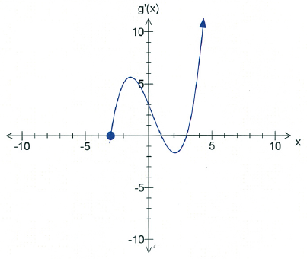

1. What can be said about the gradient of the function *g(x)* between *x* = -3 to *x* = 1?
2. When does the function, *g(x),* have a negative gradient?
3. State an equation for the tangent to the graph of *g(x)* at *x* = 3.
4. Find the value of *x* at which *g(x*) has a relative maximum for –3 ≤ x ≤ 4
5. Find the *x*-coordinate of each point of inflection of the graph of *g(x)* for

–3 ≤ x ≤ 4

8. [ 1,2,2,2 = 7 marks ]

A particle is moving in rectilinear motion with acceleration ‘*a*’ at any time ‘*t*’, in *m*s –2, given as

*a* = 6*t* – 1

Initially, the particle is at the origin with a velocity of -*2m/s.*

Determine

1. The velocity of the particle at any time *t*.
2. When the particle is again at the origin.
3. The minimum velocity of the particle.
4. The total distance travelled by the particle in the first three seconds.

9. [2, 3, 3, 3, 1 = 12 marks]

The diagram shows an arched church wooden window frame, to be made from 10m of timber.

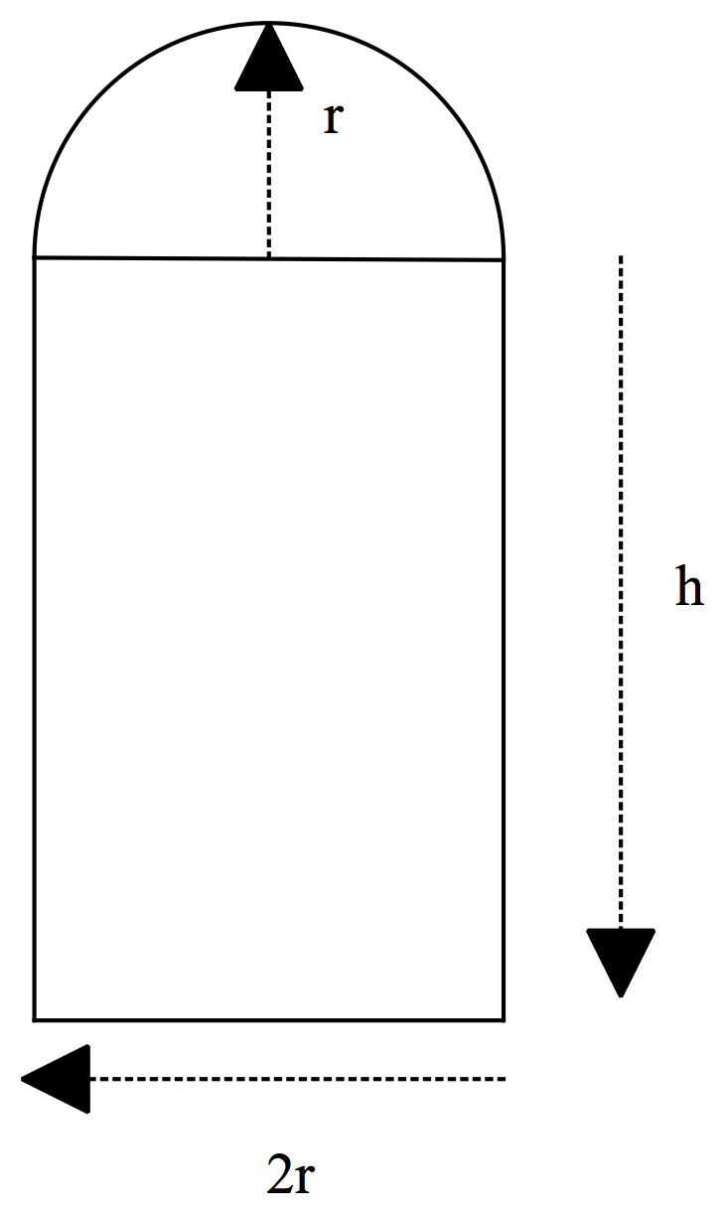

1. Find an expression for *h* in terms of *r.*
2. Show that the area of the window is *A* = 10*r – r2 (*4 *+ )*

Hence, or otherwise,

1. Show that the **exact** value of r that maximises the area is *r* = $\frac{10}{8+ π}$
2. Suppose the radius *(r)* is increased by 10cm. Find the approximate change, using calculus methods, in the height of the window if the 10m of timber restriction still applies.
3. Interpret your answer in part *(d).*

10. [2, 2 = 4 marks]

1. The graph of *f(x)* is shown. Sketch the graph of the derivative function for *f(x)* on the axes below.

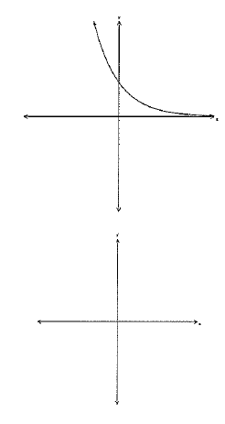

1. Given the derivative function, sketch the graph of the function for on the axes below.

